**PH233 End-semester exam Module D: Difference Amplifier**

The final ingredient required to complete the feedback control system is a difference amplifier: the blue block at the left shown in Fig 1

AIM of this module: Design and make a Difference amplifier (blue block that subtracts two voltages

**PLANT (Modules A+B)**

CONTROLLER  
(Module C)

–

**+**

Design and build a DIFFERENCE amplifier with UNITY GAIN which has two voltage inputs . It must implement the voltage subtraction

As you see in Fig 1, when we put it into our feedback control system, it will be used to calculate the error in the feedback loop: which is then input to the P feedback controller as

This difference amplifier must be a simple design with one opamp, 4 resistors of equal value and +1 gain. Choose reasonably high value resistors so as to not cause impedance loading effects on the sources providing V1 & V2

**Circuit design and simulation (LTSpice) 5**

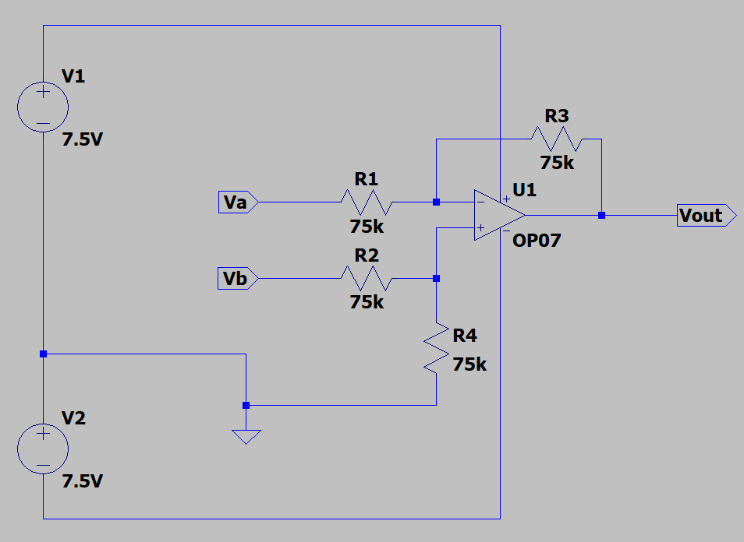

*NOTE: 7.5V has been used in place of the standard 9V due to draining of my battery after prolonged usage, as well as due to the protection circuit used in the breadboard.*

In the above circuit, Vout = Vb – Va (with unity gain).

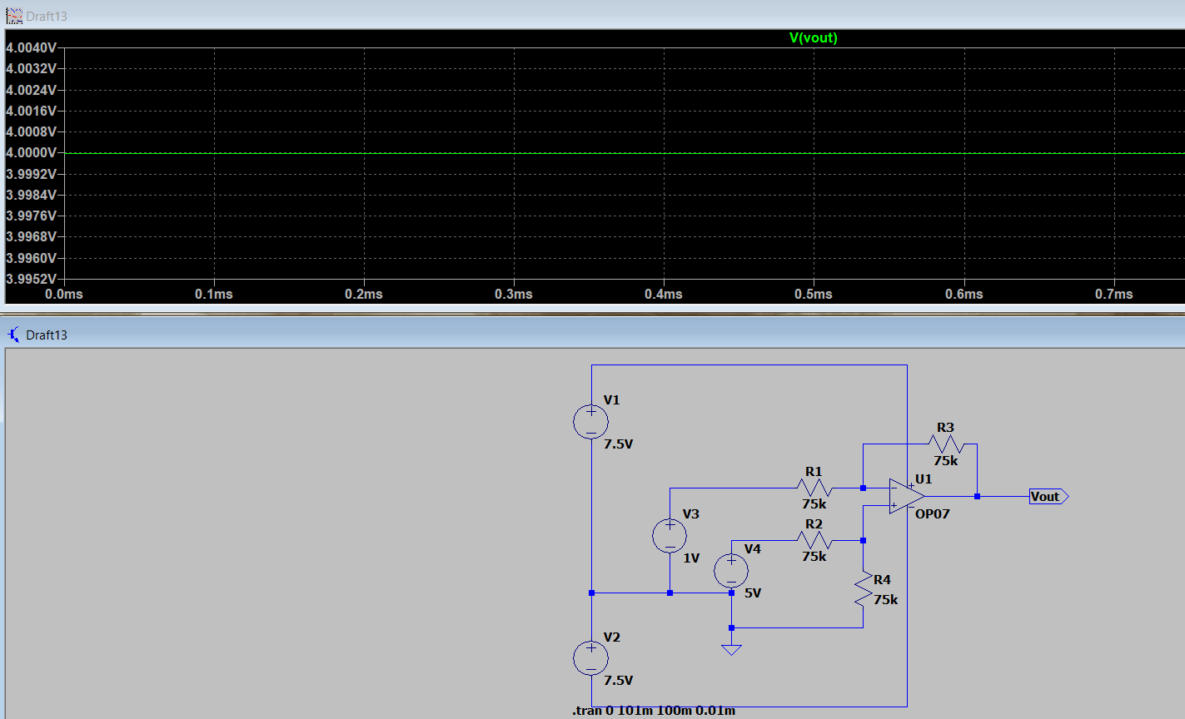

Choosing, Va = 1V and Vb = 5V for example, we get the desired output Vout = (5-1)V = 4V

Photos of built up difference amplifier circuit. You may need to hand-pick resistors of precisely matched values to get unity gain.   
Note: DO NOT connect the difference amplifier into the full feedback loop yet. Perform the following tests applying DC voltage inputs to your difference amplifier inputs by itself to make sure it works fine. Test your circuit input output with a DMM. Verify measurements for the following sets of inputs and outputs **5**

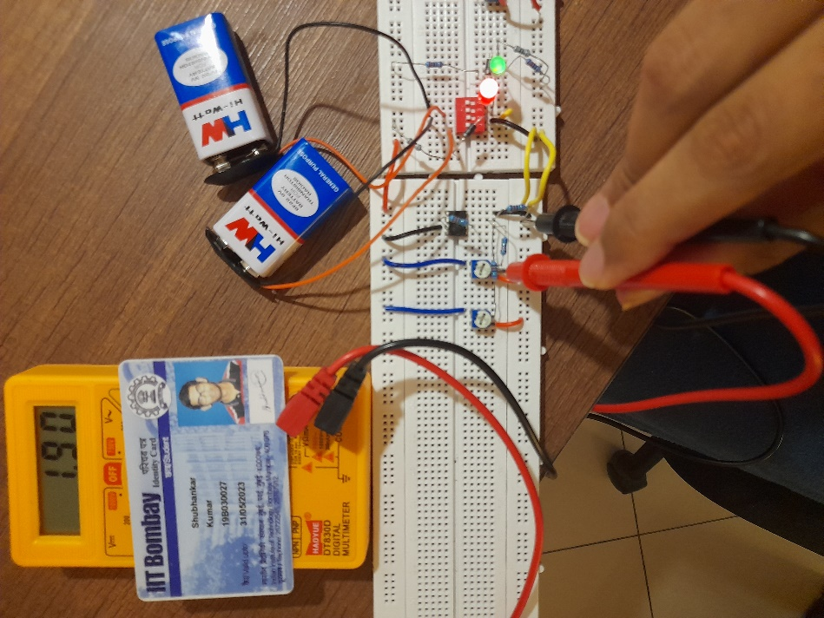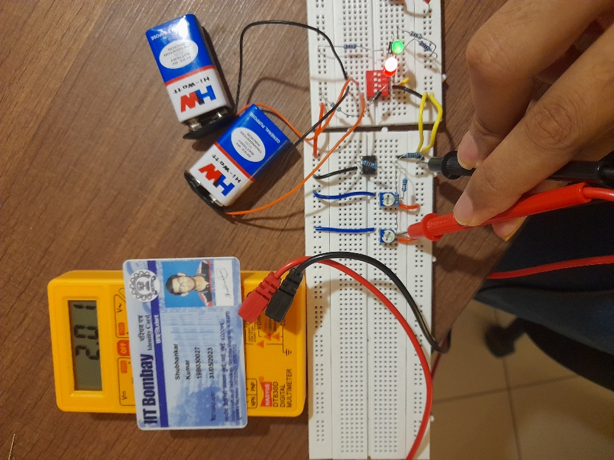

**V1 = 2.01V V2 = 1.9V**

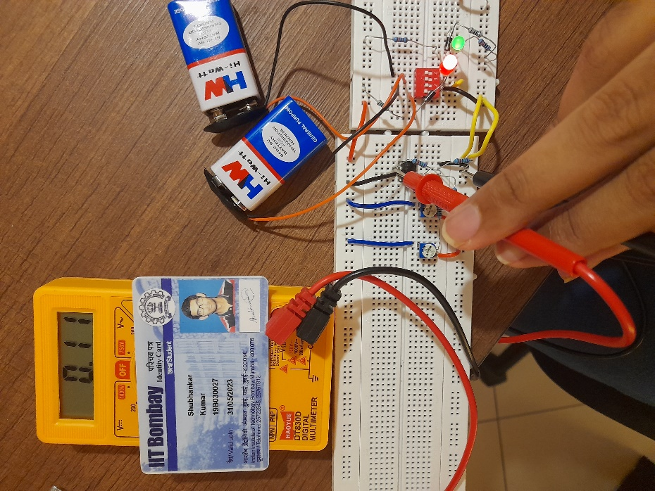

**VOUT = 0.11V**

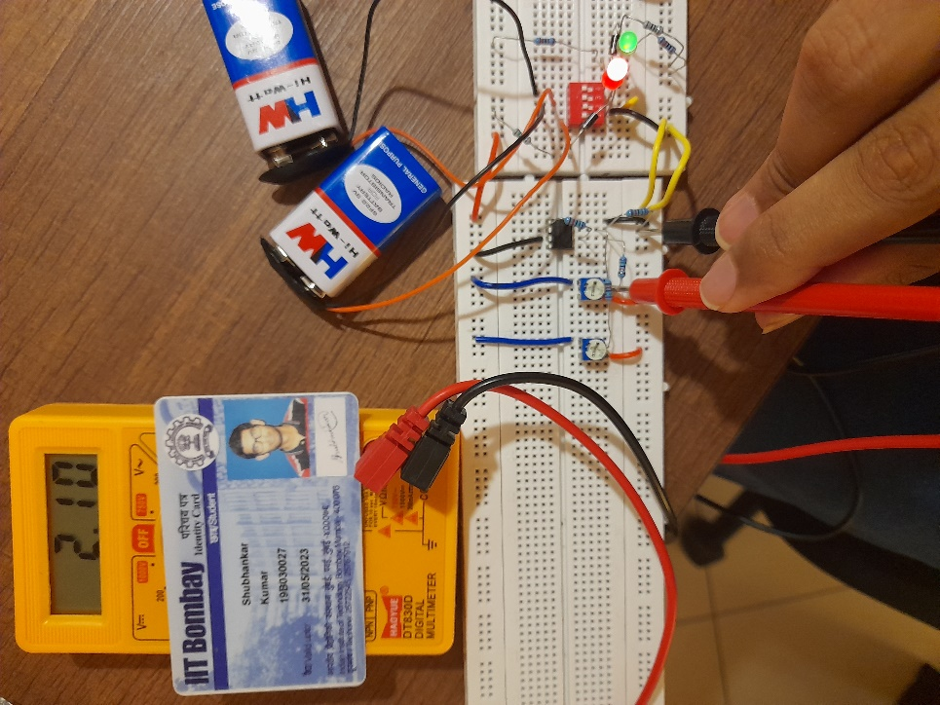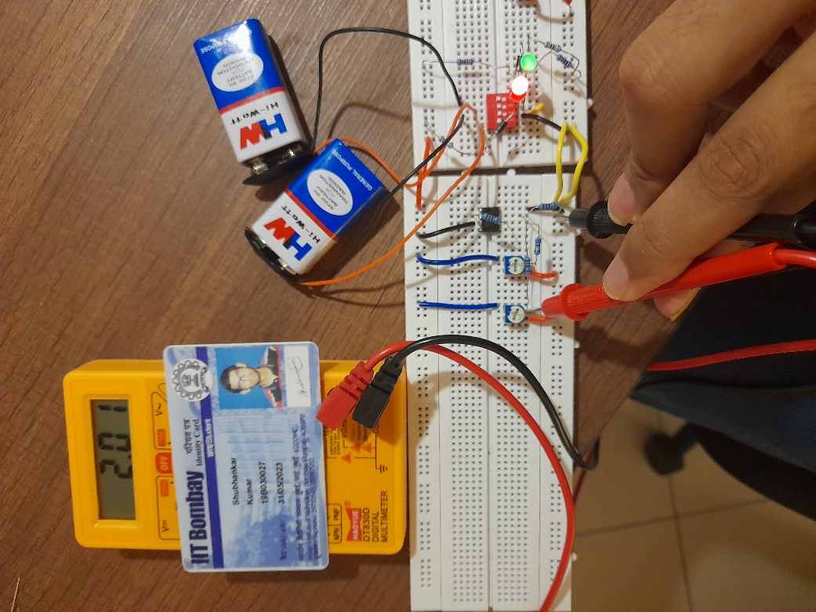

**V1 = 2.01V V2 = 2.1V**

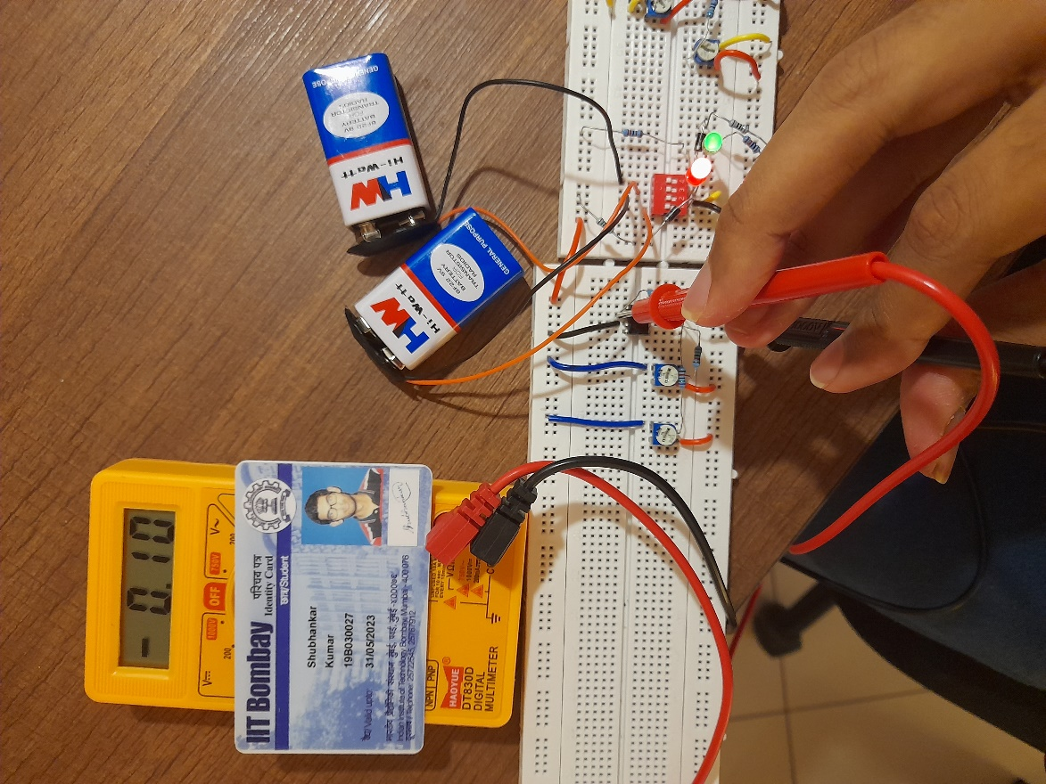

**VOUT = -0.1V**